# DATA PERCOBAAN I

1. **Karakteristik Dioda (1)**

Tabel 1.1

|  |  |
| --- | --- |
| **Rangkaian** | **Arus ( mA )** |
| Forward Bias  Reverse Bias | 2.00  0 |

# Karakteristik Dioda (2)

Tabel 1.2

|  |  |  |  |
| --- | --- | --- | --- |
| Vs (V) | Vr (V) | Vd = Vs – Vr (V) | If = Vr x 10 (mA) |
| 0  0.1  0.3  0.7  0.9  1.1  1.5  2.0  3.0 | 0  0  0  0  0  0.01  0.03  0.06  0.14 | 0  0.1  0.3  0.7  0.9  1.0  1.12  1.94  2.86 | 0  0  0  0  0  0.11  0.33  0.67  1.40 |

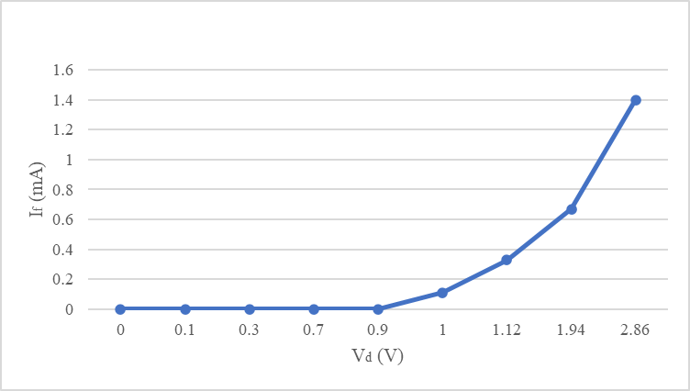

Gambar 1.1

# Penyearah Setengah Gelombang (Halfwave Rectifier)

VR = 5.159 volt (Langkah 2) VR = 9.173 volt (Langkah 5)

# Dioda Zener

Tabel 1.3

|  |  |  |  |  |
| --- | --- | --- | --- | --- |
| Vs (V) | Vr (V) | Vd = Vs – Vr (V) | Id = Vr (mA) | Pd = Vd x Id (mW) |
| 0  4  6  6.5  7  8  10 | 0  4.1 x 10-6  6.1 x 10-6  6.6 x 10-6  7.275 x 10-6  0.605  2.568 | 0  3.9999959  5.9999939  5.9999934  7.499992725  7.395  7.432 | 0  4.1 x 10-6  6.1 x 10-6  6.6 x 10-6  7.275 x 10-6  0.605  2.568 | 0  1.64 x 10-5  3.66 x 10-5  3.96 x 10-5  5.46 x 10-5  4.474  19 |

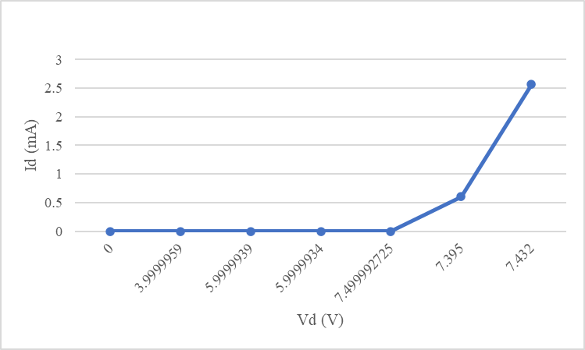

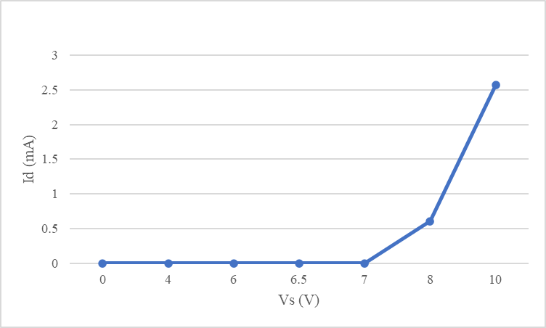

Gambar 1.2 (a. Vd & Id, b.Vd & Is)

# DATA PERCOBAAN II

**A. Tabel Karakteristik Output Transistor Mencari nilai Vce= V**

|  |  |  |  |  |  |  |
| --- | --- | --- | --- | --- | --- | --- |
|  | | Ic (mA) | | | | |
| 0,5 | 1 | 2 | 5 | 10 |
| Ib(uA) | 0 |  |  |  |  |  |
| 10 |  |  |  |  |  |
| 30 |  |  |  |  |  |
| 50 |  |  |  |  |  |

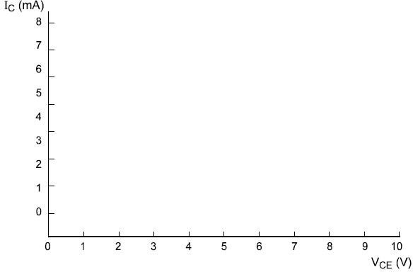

Gambar 2.1

Tabel 2.2

|  |  |
| --- | --- |
| IB (µA) | IC |
| 20 |  |

|  |  |
| --- | --- |
| 10 |  |

Gambar 2.2 Gambar 2.3

Gambar 2.4 Gambar 2.5

# DATA PERCOBAAN III

1. Distorsi
2. Umpan Balik Negatif
3. Pengaruh frekuensi

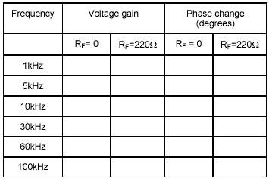Tabel 3.1

1. Inverter

Tabel 3.2

|  |  |
| --- | --- |
| **input** | **Output (volt)** |
| 0 |  |
| 1 |  |

# DATA PERCOBAAN IV

1. Multistage Amplifier - Stage A

* Stage B
* Full stage

1. Phase Shift Oscillator
2. Gerbang NAND

|  |  |  |  |
| --- | --- | --- | --- |
| **Switch 1** | **Switch 1** | **Switch 1** | **Output (volt)** |
| 0 | 0 | 0 |  |
| 0 | 0 | 1 |  |
| 0 | 1 | 0 |  |
| 0 | 1 | 1 |  |
| 1 | 0 | 0 |  |
| 1 | 0 | 1 |  |
| 1 | 1 | 0 |  |
| 1 | 1 | 1 |  |

# DATA PERCOBAAN V

A.

B.

C